 | My End to End Data overflow | 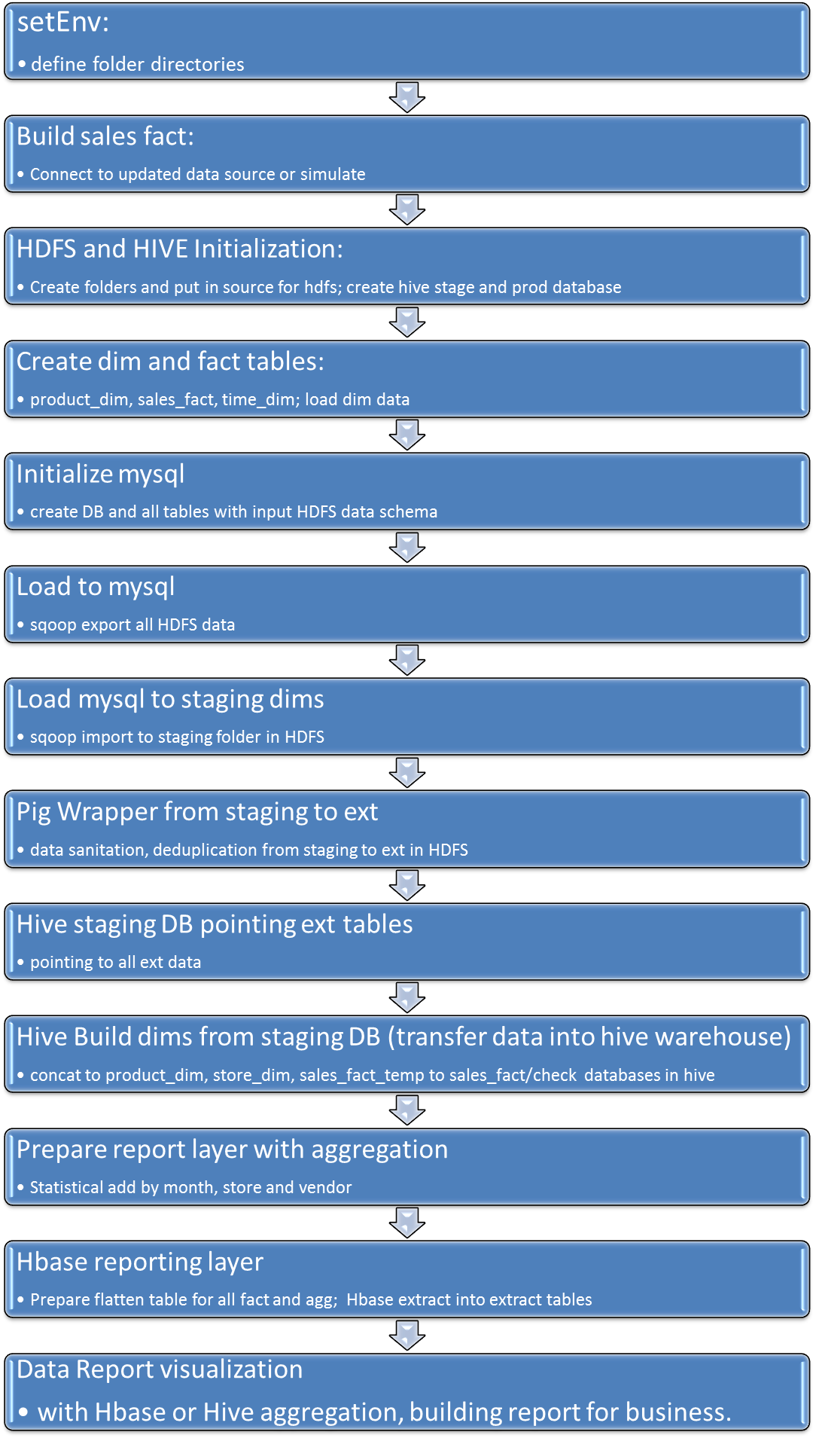
 | simulate realtime sales table  build_sales_fact.sh | sh build_sales_fact.sh 1000 0 sales.dat  echo $trans_date$sep$store_id$sep$dept_id$sep$vendor_id$sep$style_id$sep$color$sep$size$sep$unit_price$sep$sales_units$sep$sales_dolrs>>$3  (( count++ ))  done
0 | Project prepare  Create HDFS folders  put data to HDFS  hive database create  prepare_project.sh | #!/bin/bash  # create HDFS data file folders and copy data files to source_data folder  hadoop fs -mkdir /user/training/project  hadoop fs -mkdir /user/training/project/EDW  hadoop fs -mkdir /user/training/project/EDW/source_data  hadoop fs -mkdir /user/training/project/EDW/staging  hadoop fs -mkdir /user/training/project/EDW/ext  hadoop fs -mkdir /user/training/project/EDW/ext/sales  hadoop fs -mkdir /user/training/project/EDW/ext/dept  hadoop fs -mkdir /user/training/project/EDW/ext/vendor  hadoop fs -mkdir /user/training/project/EDW/ext/style  hadoop fs -mkdir /user/training/project/EDW/ext/store  hadoop fs -mkdir /user/training/project/EDW/ext/time_dim  hadoop fs -mkdir /user/training/project/EDW/output  #copy data files to source_data folder  for i in /home/training/exercises/project/sale/sale_data/*.dat  do  hadoop fs -put -f $i /user/training/project/EDW/source_data  done  # create stage and prod databases in hive  hive -e 'create database if not exists retail_stage;'  hive -e 'create database if not exists retail_prod;'
 | create mysql tables  create_mysql_tabs.sql | # creates mysql tables  create database if not MDM  use MDM;  create table dept(dept_id integer,dept_name varchar(30));  create table vendor(vendor_id integer,vendor_name varchar(30));  create table style(style_id integer,style_name varchar(30));  create table store(store_id integer,store_name varchar(30),address varchar(30),city varchar(20),state varchar(2),store_type char(1));  create table sales(trans_date integer,store_id integer, dept int,vendor integer, style integer, color varchar(15), size integer,unit_price double,sales_units integer, sales_dolrs double);
 | sqoop export  mysql://localhost/MDM  load_mysql.sh | # exports 5 data files from hdfs location to mysql db  sqoop export --connect jdbc:mysql://localhost/MDM --table dept --username root --password root --export-dir /user/training/project/EDW/source_data/dept.dat
 | Hive prepare  fact and dimension table  sales_fact product_dim  time_dim  prepare_hive.sql | use retail_prod;  create table if not exists product_dim(product_id int,dept_id int, dept_name string, vendor_id int, vendor_name string,  style_id int, style_name string, color string, size int) row format delimited fields terminated by ',';  create table if not exists sales_fact(product_id int,trans_date int,store_id int,unit_price double, sales_units int,  sales_dolrs double) row format delimited fields terminated by ',';  create table if not exists time_dim(trans_date int, week int, month int, year int) row format delimited fields terminated by ',';  truncate table time_dim;  load data inpath '$SOURCE_DIR/time_dim.dat' into table time_dim;
1 | Data ingestion  load_dims.sh | #Moving mysql MDM database 5 tables to different HDFS staging folders  #!/bin/bash  SRC_DIR=/user/training/project/EDW/staging  LOG_DIR=/home/training/exercises/project/log  # remove existing directories  hadoop fs -rm -R $SRC_DIR/dept $SRC_DIR/store $SRC_DIR/style $SRC_DIR/vendor  sqoop import --connect jdbc:mysql://localhost/MDM --table dept --username root --password root -m 1 --target-dir /user/training/project/EDW/staging/dept
2 | Data transformation  2 ext folders in HDFS  Pig sanity check  pigWrapper.sh | STAG_DIR=/user/training/project/EDW/staging  TRG_DIR=/user/training/project/EDW/ext  SCRIPT_DIR=/home/training/exercises/project/sale/build  pig -b -param stage=$STAG_DIR -param target=$TRG_DIR -f $SCRIPT_DIR/process_sales.pig  pig -b -param stage=$STAG_DIR -param target=$TRG_DIR -f $SCRIPT_DIR/deduplicate.pig
2.1 | process sales table  process_sales.pig | #take out negative sale value, sorted by data for all  sales = load '$stage/sales' using PigStorage(',') as (transdate:int,store_id:int,dept:int,vendor:int, style:int, color:chararray, size:int, unit_price:double, sales_units:int, sales_dolrs:double);  sales_good = filter sales by sales_units>0; sales_dedup = distinct sales_good; sales_order = order sales_dedup by transdate;  fs -rmr $target/sales; store sales_order into '$target/sales' using PigStorage(',');
2.2 | duduplicate  dept style vendor store tables  deduplicate.pig | dept = load '$stage/dept/*';  dept_dedup = distinct dept;  fs -rmr $target/dept  store dept_dedup into '$target/dept' using PigStorage(',');
3 | create external table in Hive stage database  2 ext hive  Prepare for hive output database  create_ext.sql | # create 5 staging tables in database retail_stage (dept_stage vendor_stage style_stage store_stage sales_stage)  use retail_stage;  create external table if not exists dept_stage(dept_id int,dept_name string)  row format delimited  fields terminated by ','  location '${TRG_DIR}/dept';
4 | Building fact and dimension Tables  Data Warehouse  in hive  take data from staging database to product database in hive  build_dims.sh | # build product_dim dimension table product_id (concat 5 numbers), color, size from all four stage tables in database retail_stage  #build sales_fact table from sales_fact_temp table  #Actual setup partitions, update just within this partition (day/week/month)  hive <<eof  use retail_prod;  truncate table product_dim;  insert into table product_dim  select concat(a.dept_id,b.vendor_id,c.style_id,s.size,(case s.color when 'black' then 1 when 'red' then 2 when 'white' then 3 when 'yellow' then 4 end )) as product_id, a.dept_id, a.dept_name, b.vendor_id, b.vendor_name, c.style_id, c.style_name, s.color as color, s.size as size from retail_stage.dept_stage a join retail_stage.sales_stage s on (a.dept_id=s.dept) join retail_stage.vendor_stage b  on (s.vendor=b.vendor_id) join retail_stage.style_stage c on (s.style=c.style_id) ;  #sales_fact_temp with product_id (from product_dim), trans_date, store_id, unit_price, sales_units, sales_dolrs (from sales_stage)  drop table if exists sales_fact_temp;  create table sales_fact_temp as select b.product_id, s.trans_date, s.store_id, s.unit_price, s.sales_units, s.sales_dolrs  from retail_stage.sales_stage s join product_dim b on (concat(s.dept,s.vendor,s.style,s.size,(case s.color when 'black' then 1 when 'red' then 2 when 'white' then 3 when 'yellow' then 4 end ))=b.product_id);  truncate table sales_fact;  insert into table sales_fact select * from sales_fact_temp;  # in hive external tables in database retail_prod are accessed by the reporting team. Keep stage tables not accessed by them.
5 | Aggregation Reporting  run aggregation and de-normalized  (less join)  build_agg.sql | hive <<eof  use retail_prod;  drop table if exists dept_store_agg;  --dept_store sum all sale unit and dolrs  --Tables (sales_fact s) join (product_dim p) with groups  create table dept_store_agg as select s.trans_date, p.dept_id, p.dept_name, s.store_id, sum(s.sales_units) sales_units, sum(s.sales_dolrs) as sales_dolrs from sales_fact s join product_dim p where s.product_id=p.product_id group by s.trans_date, p.dept_id, p.dept_name, s.store_id;  drop table if exists store_month_agg;  --store_month_agg sum all month sales and price for each store  --Tables (sales_fact s) join (product_dim p) with groups  create table store_month_agg as select substr(s.trans_date,1,6) as yearmonth, s.store_id, sum(s.sales_units) sales_units, sum(s.sales_dolrs) as sales_dolrs from sales_fact s join product_dim p where s.product_id=p.product_id group by substr(s.trans_date,1,6), s.store_id;  drop table if exists vendor_month_agg;  --vendor_month_agg sum all month sales and price for each store  --Tables (sales_fact s) join (product_dim p) with groups  create table vendor_month_agg as select p.vendor_id, p.vendor_name, substr(s.trans_date,1,6) yearmonth, sum(s.sales_units) sales_units, sum(s.sales_dolrs) as sales_dolrs from sales_fact s join product_dim p where s.product_id=p.product_id group by p.vendor_id, p.vendor_name, substr(s.trans_date,1,6);  quit;  eof

